**Installation Guidelines**

Contents

**1.** **For Data Visualization Web App** 1

**2.** **For Data analysis and visualization** 5

**Covid-19 Dashboard** 8

# **For Data Visualization Web App**

For the installment and to locally run the application on your computer following major steps should be covered.

**Step 1:**  Connect to the internet and download stable version of python.

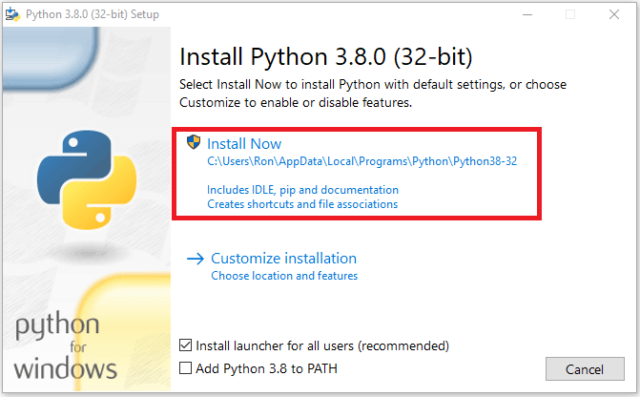

Figure 1. Download python

**Step 2:** Download PyCharm IDE to execute python code.

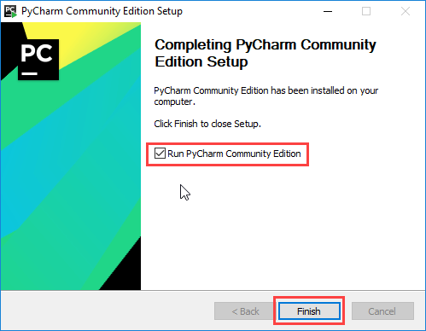

Figure 2. Download PyCharm

**Step 3:** Go the [Adityashah1999/MultiApp (github.com)](https://github.com/Adityashah1999/MultiApp) GitHub repository and download the zip file or clone the repository.

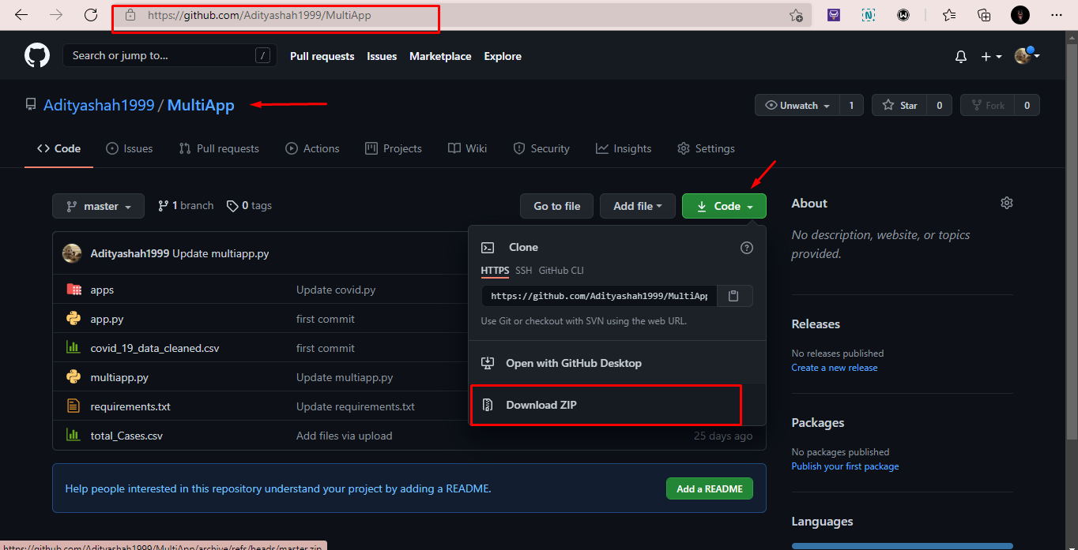

Figure 3. GitHub Repository

**Step 4:** Upload the downloaded folder into pyCharm IDE.

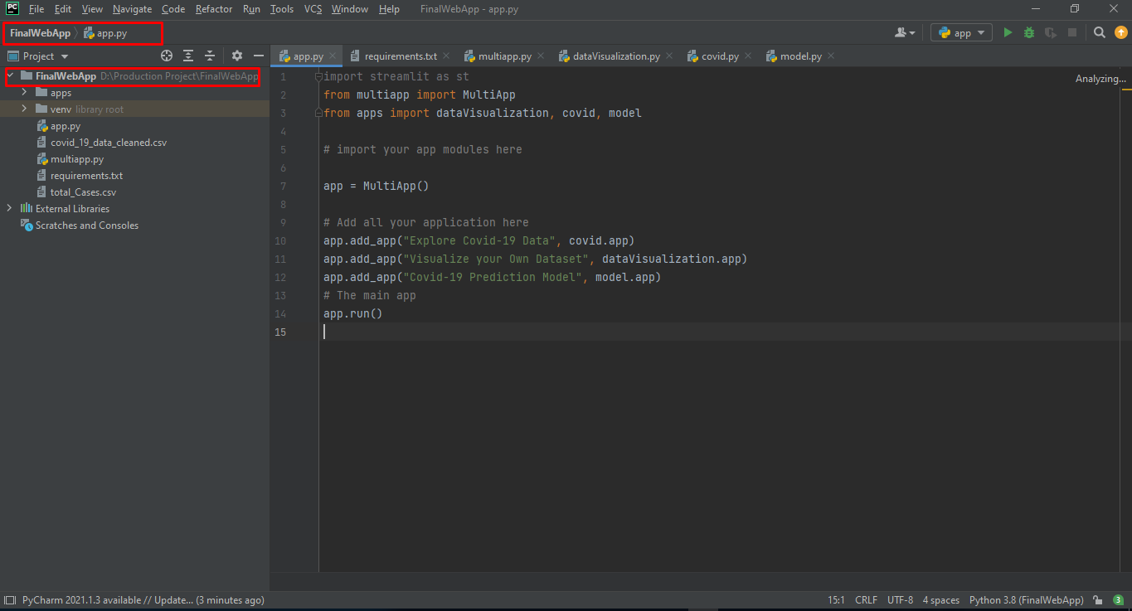

Figure 4. Upload file

**Step 5:** Install all the necessary packages from package manager and check requirements.txt file to see the requirements in order to run the program.

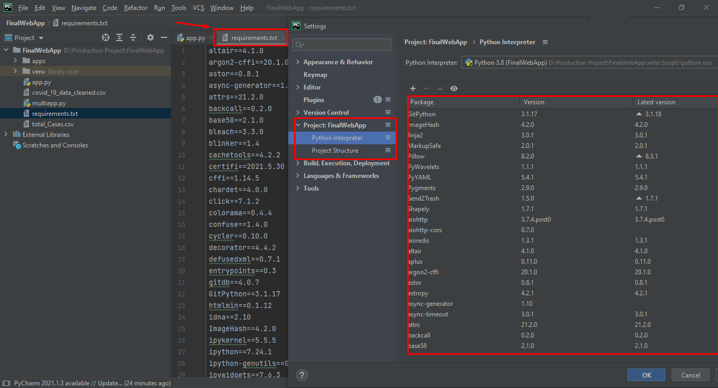

Figure 5. Install Packages

**Step 6:** After installing necessary packages go to the terminal and type ‘streamlit run app.py’ on command line and then wait for the response to show the local network. Click on the local url as shown below figure (see figure 6)

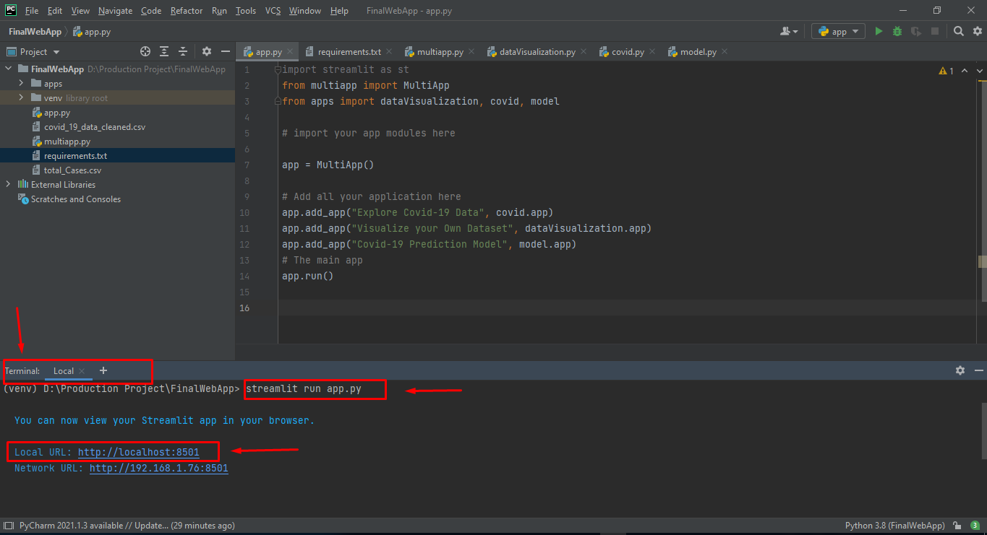

Figure 6 Run the app

**Step 7:** After clicking on local URL you will be redirected to web browser where your app will be running locally from the machine successfully.

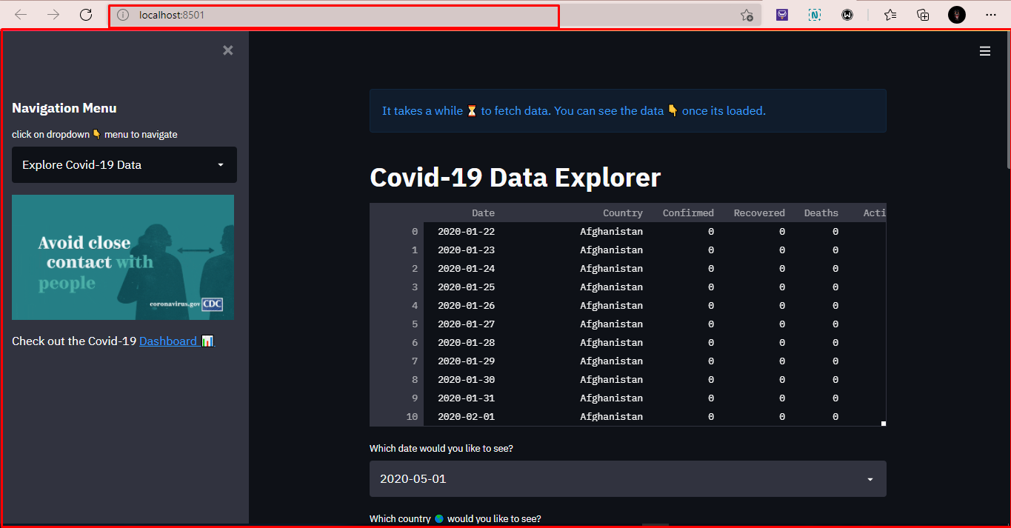

Figure 7. Run app on local machine

# **For Data analysis and visualization**

For data analysis and visualization, there is no need for installment in the local device rather you can upload a python notebook file on Google Colaboratory IDE for Visualization and perform data analysis in few steps.

**Step 1:** Connect to your internet.

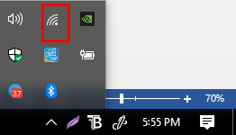

Figure 8. Connect to the internet

**Step 2:** Go to any web browser and search for google colaboratory and click on the first link of the site.

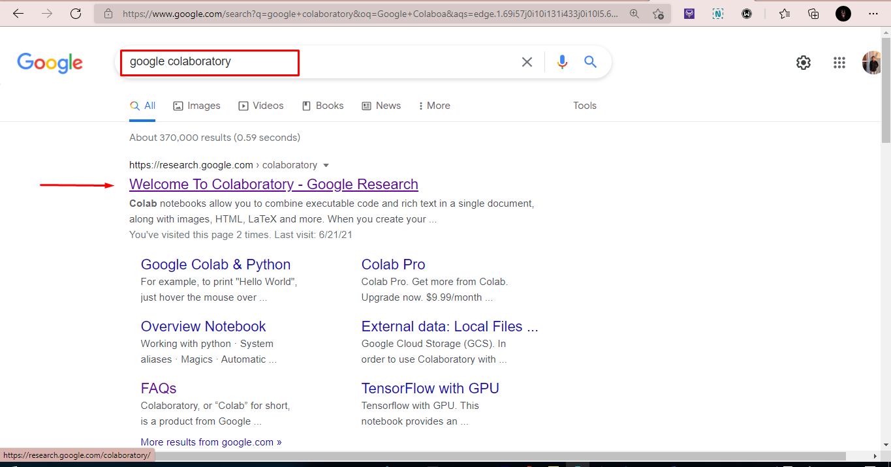

Figure 9. Search google colaboratory

**Step 3:** Open Google Colaboratory and click on the file button.

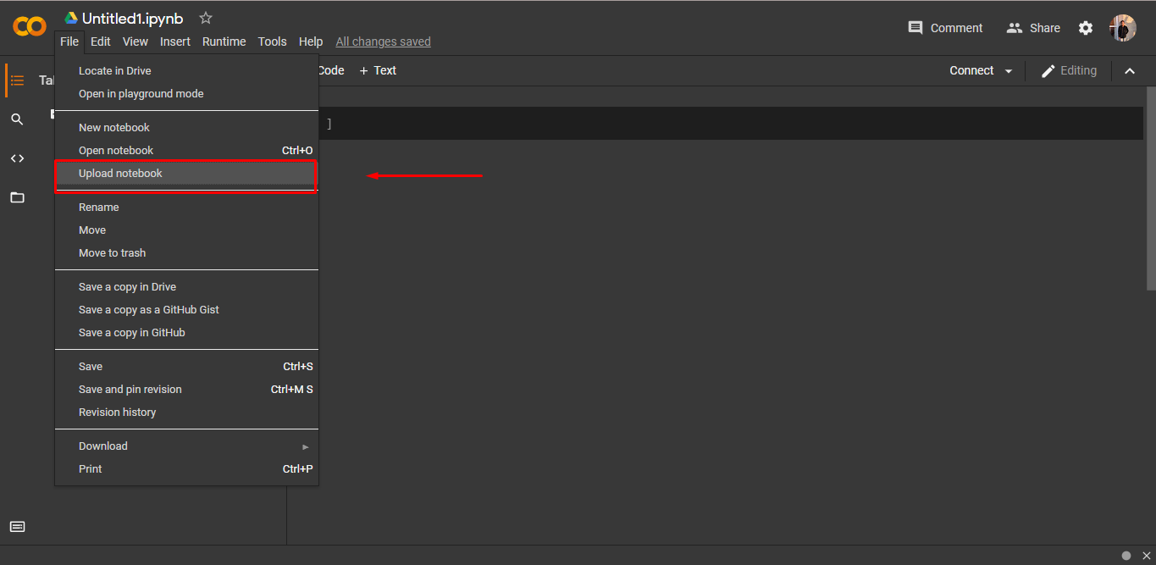

Figure 10. Select file menu

**Step 4:** Click on the upload section and choose the python notebook file from your computer.

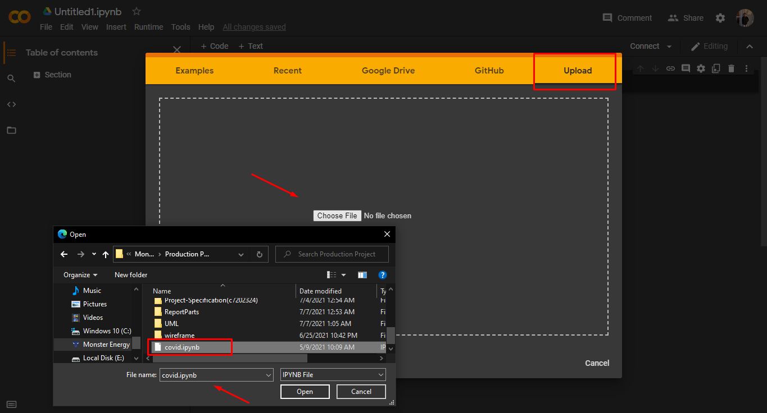

Figure 11. Upload python notebook file

**Step 5:** After uploading the file click on the runtime option and then select restart and run all options. After running every cell all data analysis and visualization results will be shown in the IDE.

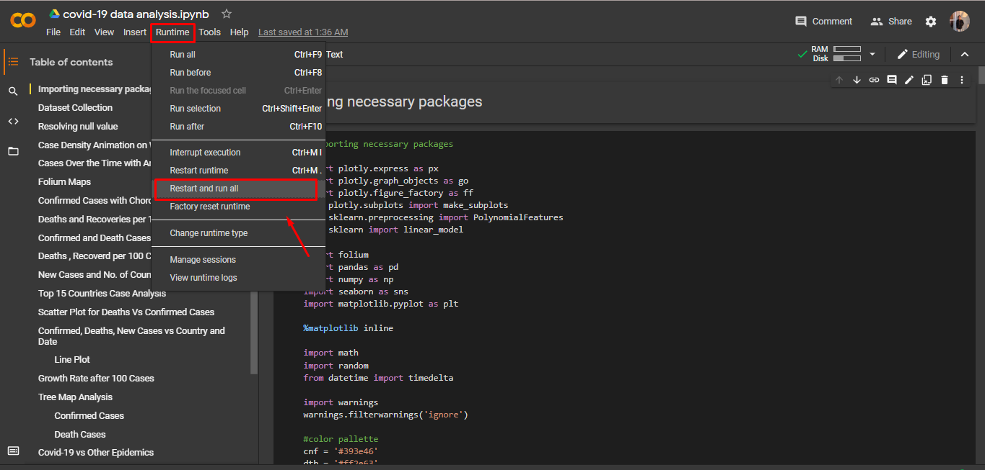

Figure 12. Restart and run

**Step 6:** Or you can visit the site <https://adityashah595728501.files.wordpress.com/2021/06/analyticsreport-1.pdf> to see the Covid-19 analytics report which is the concise result of the above data analysis and visualization.

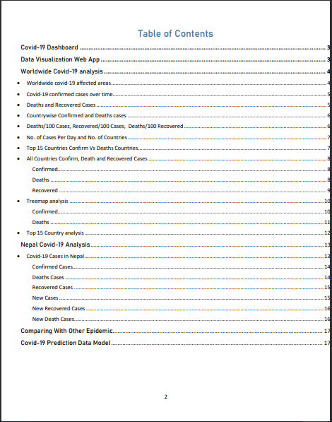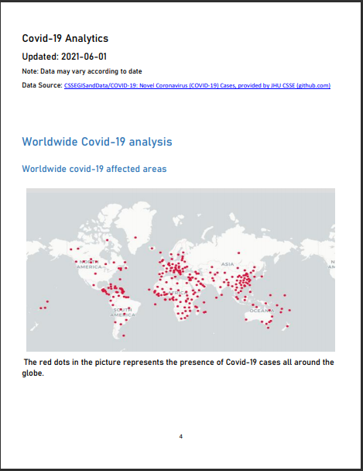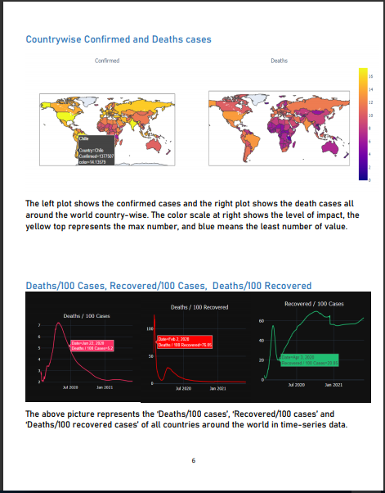

Figure 13. Visit for analytics report

# **Covid-19 Dashboard**

Since the Covid-19 dashboard is deployed online and cannot be installed locally on machine as it is not require coding manually rather built in Google data business intelligence tool. However, user can access or download the pdf report by following steps.

**Step 1:** Click on the link or go to any browser with internet connection and type <https://datastudio.google.com/embed/reporting/7c613f6a-74e3-48de-afb0-1ae1d9a68302/page/doJLC> link on address bar.

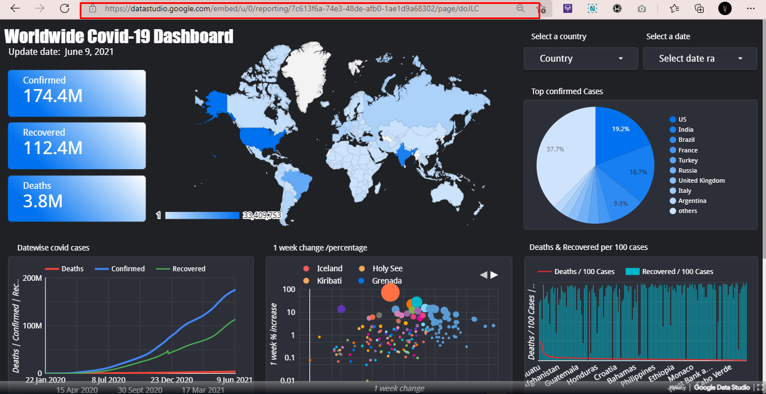

Figure 14. Dashboard link

**Step 2:** Although user can download this report in pdf format and install it on local machine or can share it with other friends (see figure 15).

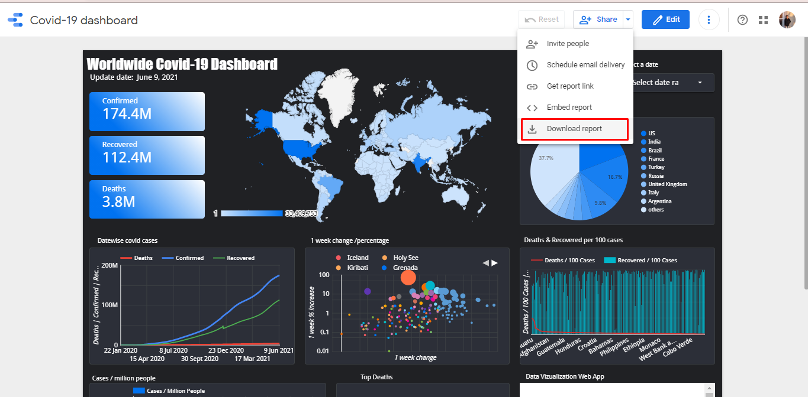

Figure 15. Download report